**LAPORAN PRAKTIKUM**

Nama : Maftuchati

NIM : 18090015

Kelas : 5B

**PRAKTIKUM 7**

1. Source Code

* Bootstrap.php -> application/controller

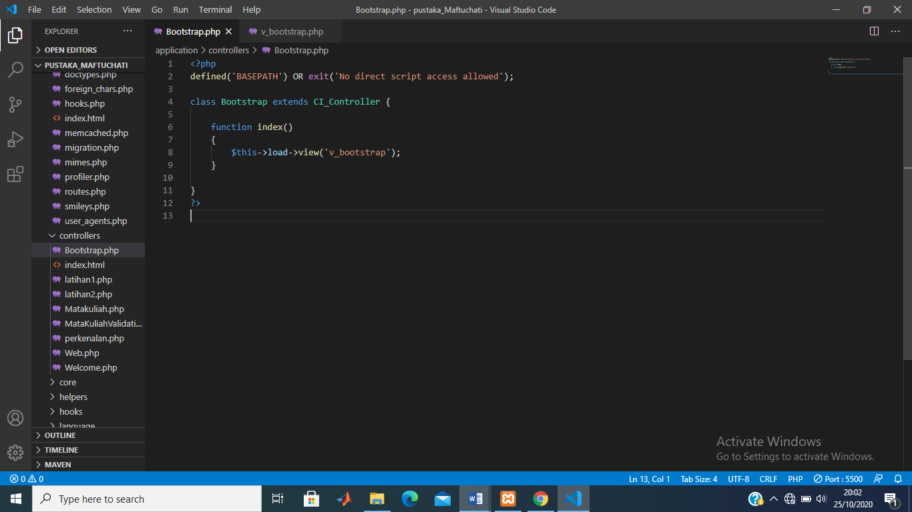

* v_bootstrap.php ->application/view

